Topics: Descriptive Statistics and Probability

- Look at the data given below. Plot the data, find the outliers and find out $μ,σ,σ^{2}$

Name of company | Measure X
Allied Signal | 24.23%
Bankers Trust | 25.53%
General Mills | 25.41%
ITT Industries | 24.14%
J.P.Morgan & Co. | 29.62%
Lehman Brothers | 28.25%
Marriott | 25.81%
MCI | 24.39%
Merrill Lynch | 40.26%
Microsoft | 32.95%
Morgan Stanley | 91.36%
Sun Microsystems | 25.99%
Travelers | 39.42%
US Airways | 26.71%
Warner-Lambert | 35.00%

Outlier Detection using Boxplot

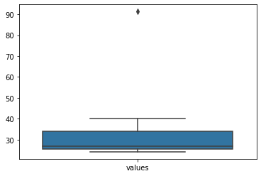

here outliers is
Morgan Stanley | 91.36%

mean = 33.27
std = 16.95
variance = 287.15

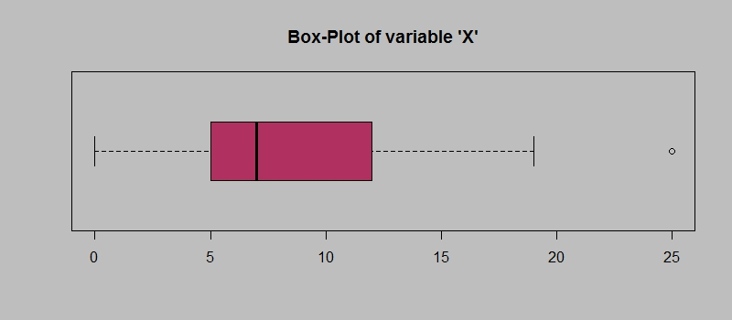
Answer the following three questions based on the box-plot above.
- What is inter-quartile range of this dataset? (please approximate the numbers) In one line, explain what this value implies.
Answer)
IQR = Q3 -Q1
IQR = 12-5 = 7
The value 25 is outlier
- What can we say about the skewness of this dataset?
Answer)
The dataset following Positive skewness (Right Skewed)
- If it was found that the data point with the value 25 is actually 2.5, how would the new box-plot be affected?
Answer)
Then the Data set don’t have outlier

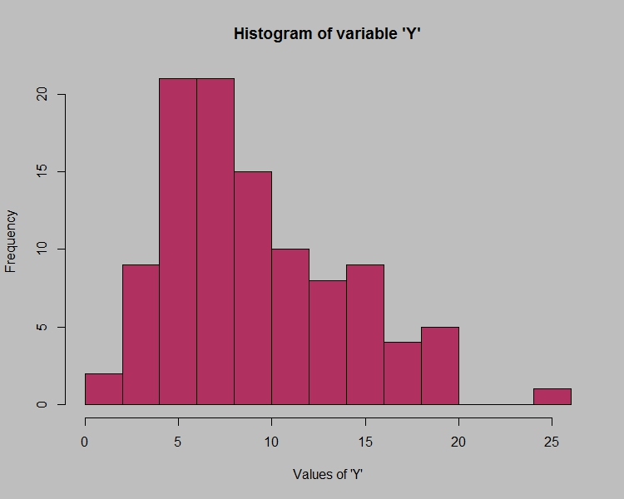

Answer the following three questions based on the histogram above.
- Where would the mode of this dataset lie? 4 to 8
- Comment on the skewness of the dataset. Right Skewed
- Suppose that the above histogram and the box-plot in question 2 are plotted for the same dataset. Explain how these graphs complement each other in providing information about any dataset.
Answer) -- by histogram we can tell mean ,median and mode of the data set,
by looking into box-plot we can’t say mode of the dataset

- AT&T was running commercials in 1990 aimed at luring back customers who had switched to one of the other long-distance phone service providers. One such commercial shows a businessman trying to reach Phoenix and mistakenly getting Fiji, where a half-naked native on a beach responds incomprehensibly in Polynesian. When asked about this advertisement, AT&T admitted that the portrayed incident did not actually take place but added that this was an enactment of something that “could happen.” Suppose that one in 200 long-distance telephone calls is misdirected. What is the probability that at least one in five attempted telephone calls reaches the wrong number? (Assume independence of attempts.)

p of misdirecting calls = 1/200
p of not misdirecting call = 1- 1/200 = 199/200
p(al least one in five attempted call reaches the wrong number)
= 1 – p(no attempted call reaches the wrong number)
= 1 – (199/200)⁵ = 0.02475

- Returns on a certain business venture, to the nearest $1,000, are known to follow the following probability distribution
x | P(x)
-2,000 | 0.1
-1,000 | 0.1
0 | 0.2
1000 | 0.2
2000 | 0.3
3000 | 0.1

- What is the most likely monetary outcome of the business venture?
Answer = 2000 it has 0.3 probability
- Is the venture likely to be successful? Explain
p(success) = 0.2+0.3+0.1 = 0.6 probability
it has more probability to successful that loss
- What is the long-term average earning of business ventures of this kind? Explain
∑x * p(x)
= (-2000*0.1)+(-1000*0.1)+(1000*0.2)+(0*0.2)+(2000*0.3)+(3000*0.1)
= 800
- What is the good measure of the risk involved in a venture of this kind? Compute this measure
Answer = 0.08164966

